7KEV -

Functionality
This function lets you copy plan data from previous year to create a new plan in Profit Center Accounting. For example, it might be useful to use the plan values of the last year as a basis for you plan for the coming year.

Scenario
Copy Plan of: Year 2002/Profit Center 7000/Account 420502; to year 2003.

Requirements
Plan version was maintained for relevant year. Actual data were posted.

Menu Path | Accounting → Controlling → Profit Center Accounting → Planning → 7KEV - Copy Data to Plan
Transaction Code | 7KEV

1. Double click on 7KEV - Copy Data to Plan.

Copy to Plan: Initial Screen

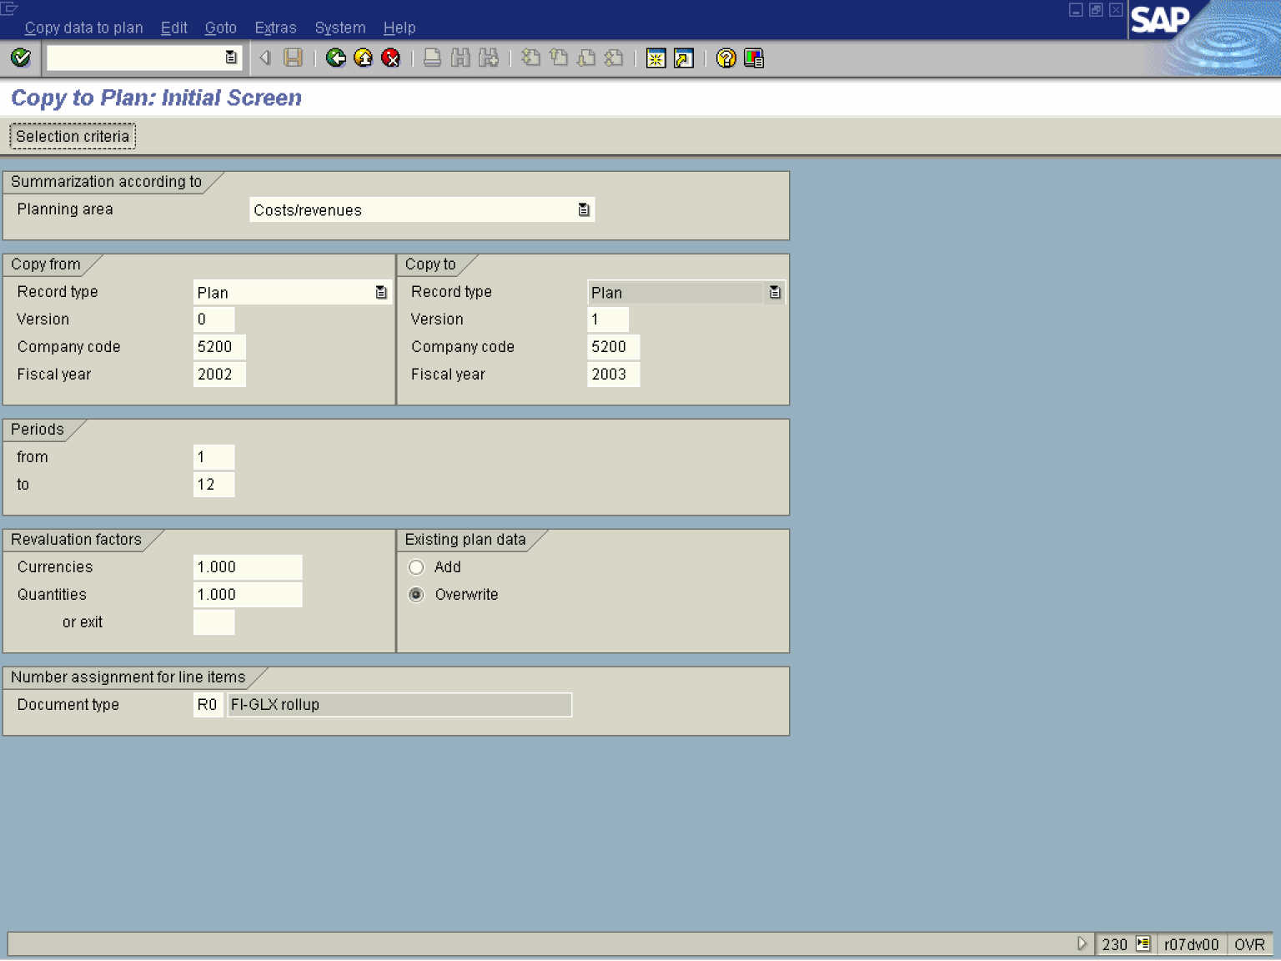

2. Select the Costs/revenues in dropdown.

3. Select the Plan in dropdown.

4. Update the following fields:

Field Name | Field Description | Values
Version | Number which represents the planning version | Example: 0
Company code | Code identifying the company | Example: 5200
Fiscal year | Description of the Fiscal year. | Example: 2002

Copy to Plan: Initial Screen

5. Update the following fields:

Field Name | Field Description | Values
Version | Number which represents the planning version | Example: 0
Company code | Code identifying the company | Example: 5200
Fiscal year | Description of the Fiscal year. | Example: 2003

6. Click the Overwrite radio button.

7. Click the Enter button.

Copy to Plan: Initial Screen

8. Click the Selection criteria button.

Copy to Plan (Costs/Revenue): Selection

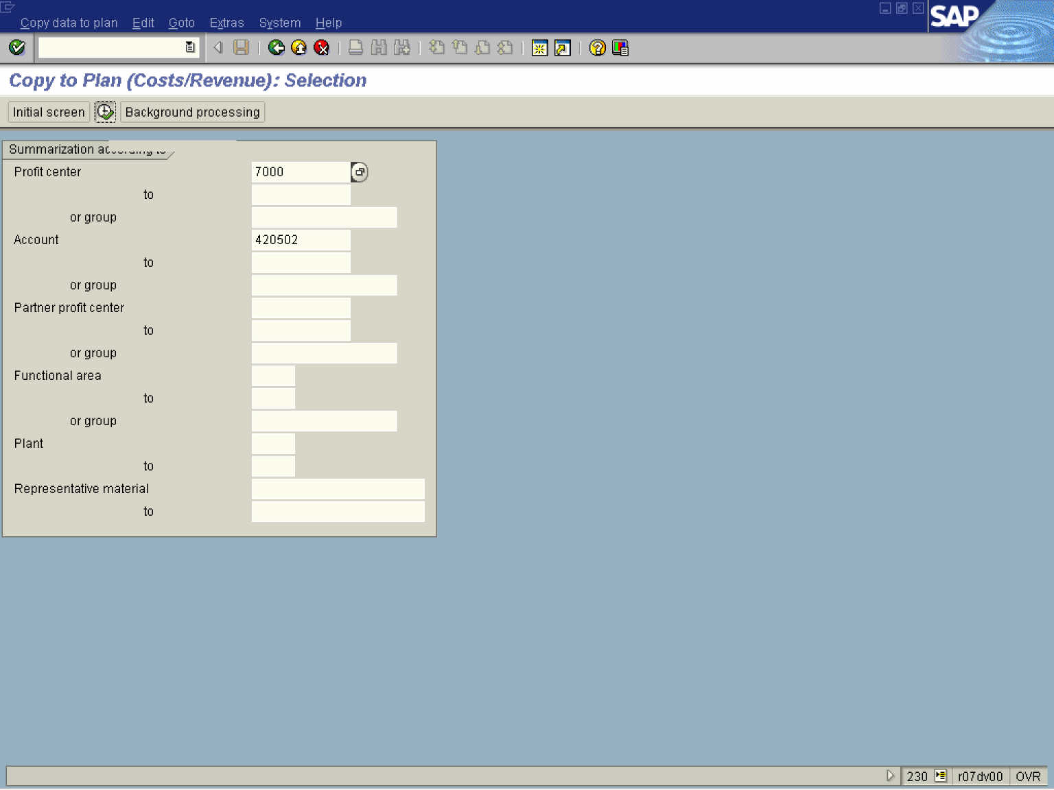

9. Update the following fields:

Field Name | Field Description | Values
Profit center | Code identifying an organizational object for which an independent operating profit is calculated | Example: 7000
Account | Code identifying the General Ledger, Vendor, or Customer account | Example: 420502

10. Click the Enter button.

11. Click the Execute button.

Copy Model Plan

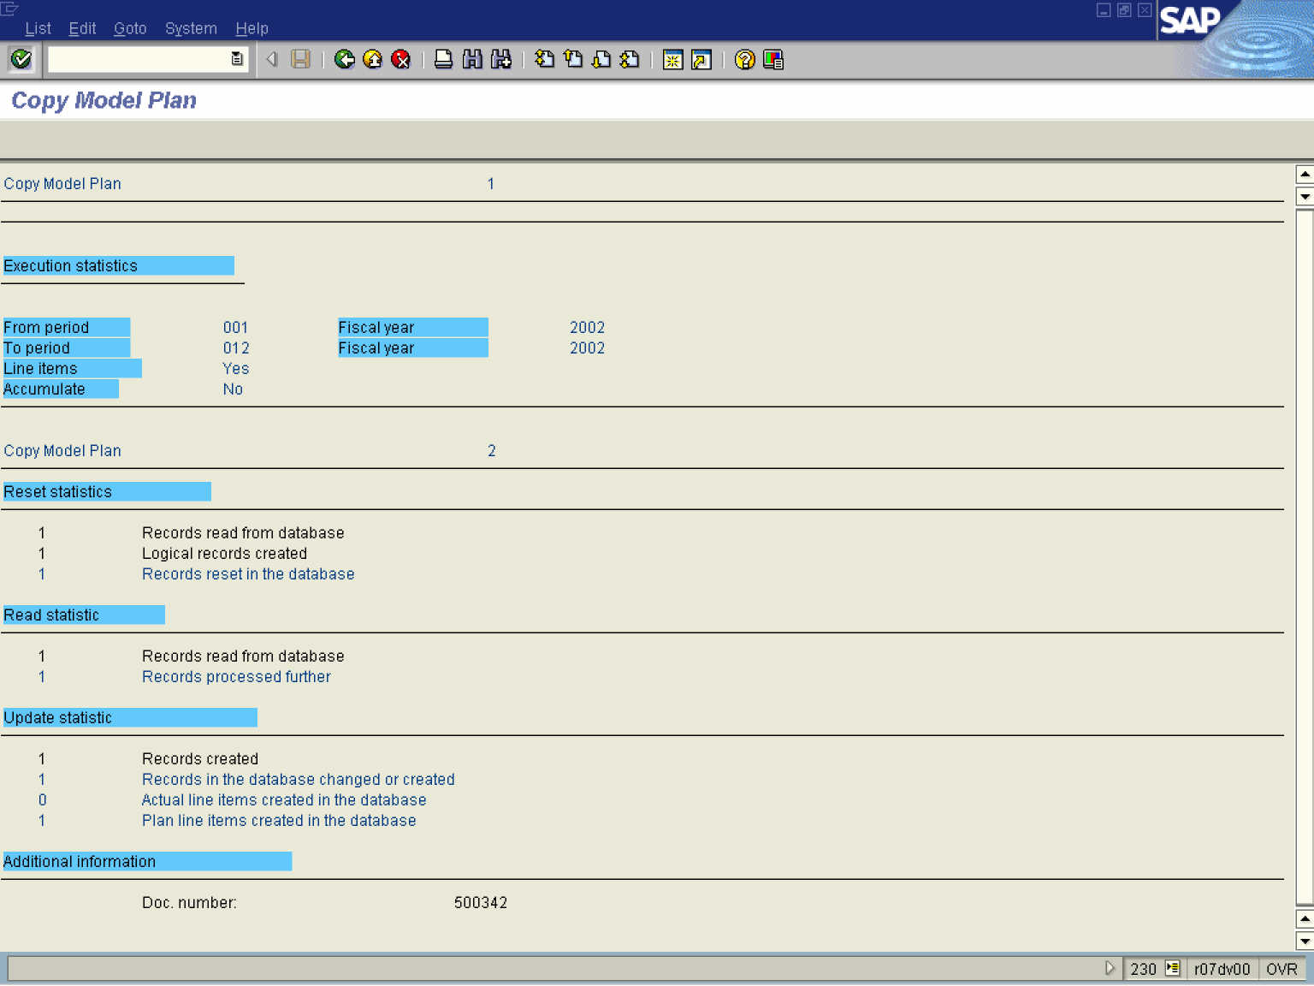

12. Click the Back button.

Copy to Plan: Initial Screen

13. Click the Back button to go back to SAP Easy Access screen.

